Pin correspondence:

RFID模块 Arduino (UNO)
VCC 3.3V
RST 5
GND GND
MISO 12
MOSI 11
SCK 13
NSS 10
IRQ (nc)
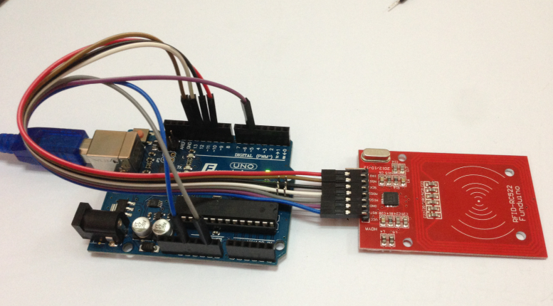
experimental result：
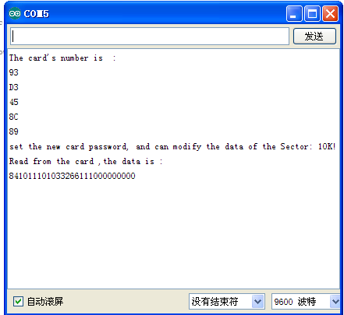
Card number for：0x93,0xd3,0x45,0x8c,0x89

RFID is the radio frequency identification technology.

Radio frequency identification that RFID (radio frequency identification) technology, also known as radio frequency identification (RFID) is a kind of communication technology, through radio signals to identify a specific target and to read and write data, without the need to identify system and the specific goal established between the mechanical or optical contact. Commonly used low frequency (125k~134.2K) and high frequency (13.56MHz), UHF, microwave technology of RFID reader is divided into mobile and stationary, at present the application of RFID technology is very wide, such as: library entrance guard system, food safety traceability

